

User Helper

Moodle



April 16, 2018

FCIH

Helwan

1. **How to add Users :**
2. login on Moodle by admin
3. open dashboard
4. click on site administration
5. choose Users from Menu
6. click on add new user
7. fill text fields and click on Create user

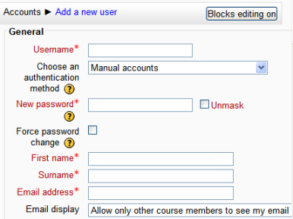

1. **How to assign role to any user :**
2. open Site Home
3. choose course from course you added it
4. click on participants from menu
5. click on enroll users button
6. search about user and give him role and click on enroll users button.

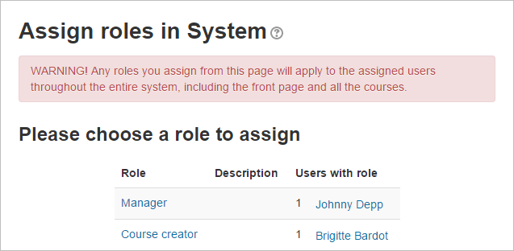

**d- How to create new course :**

1. open dashboard
2. click on site administration
3. choose Courses from Menu
4. click on Manage courses and categories
5. click on create new course from categories
6. fill text fields and save.

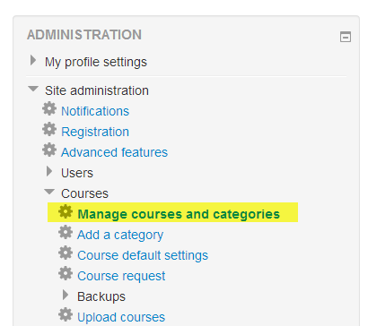

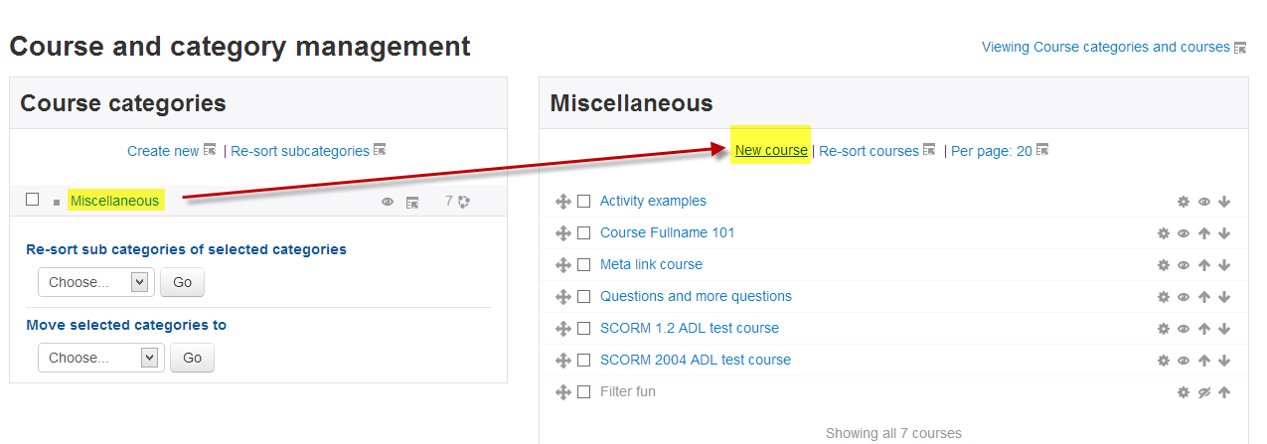

**E- How to add Teacher and Students to any course:**

1. open course by
   * open dashboard
   * click on site administration
   * choose Courses from Menu
   * click on Manage courses and categories
   * choose course and go to down to show it
2. click on enrolled users
3. click on enroll users button
4. search about users and give him student or teacher role and click on enroll users button.

**g- How to use this plugin:**

Prerequisites :

* You must have teacher access to a Moodle course.
* Teachers and students must be enrolled in the course.
* The Moodle scheduler must be installed, since it is not part of the core Moodle package.

Creating A Basic Scheduler:

1. Click the "Turn editing on" button.
2. Click the link "Add an activity or resource."
3. In the box that appears, choose "Scheduler" and click the "Add" button.  
   [Scheduler01.png](https://docs.moodle.org/32/en/File:Scheduler01.png)
4. A web page will appear called "Adding a new Scheduler." Type in the name of the scheduler, which can be changed later.
5. Scroll to the bottom of the webpage and click the "Save and display" button.
6. A webpage will appear with the name of your scheduler at the top. Click the "Add slots" link.  
   [Scheduler slots01.png](https://docs.moodle.org/32/en/File:Scheduler_slots01.png)
7. A drop-down menu will appear that allows you to add repeated slots or a single slot. Click the link to add repeated slots.
8. Options will appear to add time slots. For this lesson, the slots you add can be real or fictitious, for practice. All time slots must occur in the future, and the start time must be before the end time. The simplest option is to:
   1. Click the "Start time" menu and choose a time that is one hour from now.
   2. Click the "End time" menu and choose a time that is one hour after the start time.
9. Scroll to the bottom of the webpage and click "Save changes."

After these steps, a basic scheduler will appear. To learn more, view the scheduler as a student or explore the options below.

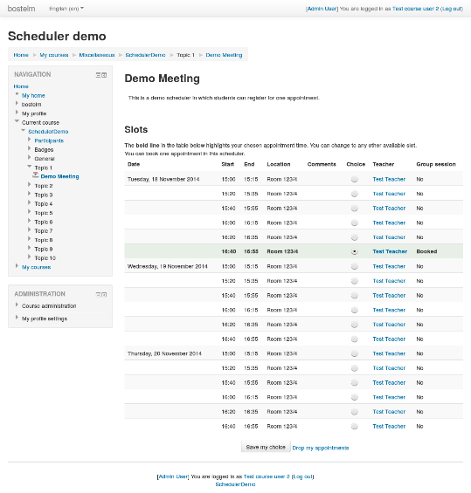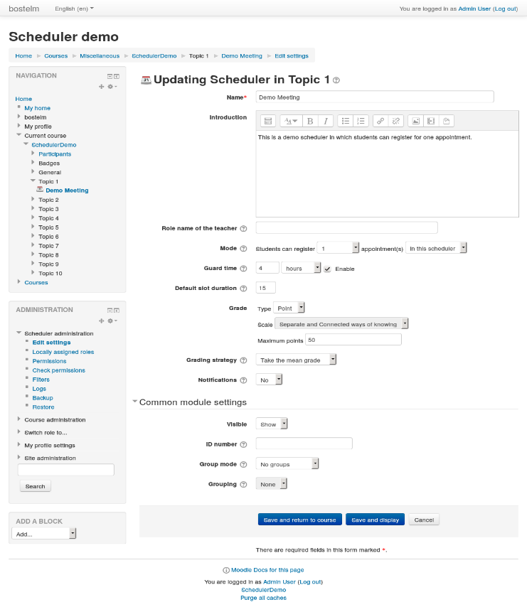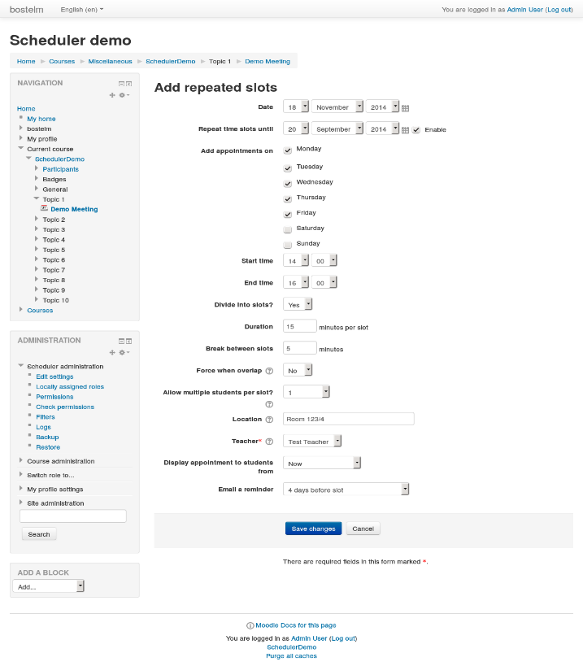

**Notification function :**

An optional notification service sends to teachers and students on certain changes:

* To teachers, when a student books or cancels an appointment,
* To students, when a teacher declines an appointment. (Note, no message is sent when the teacher *deletes* the slot instead.)

How to enable it :

This can be enabled or disabled on each Scheduler's settings page.

Scheduler also sends reminders of upcoming appointments to students, if the teacher has selected this on a per-slot basis.

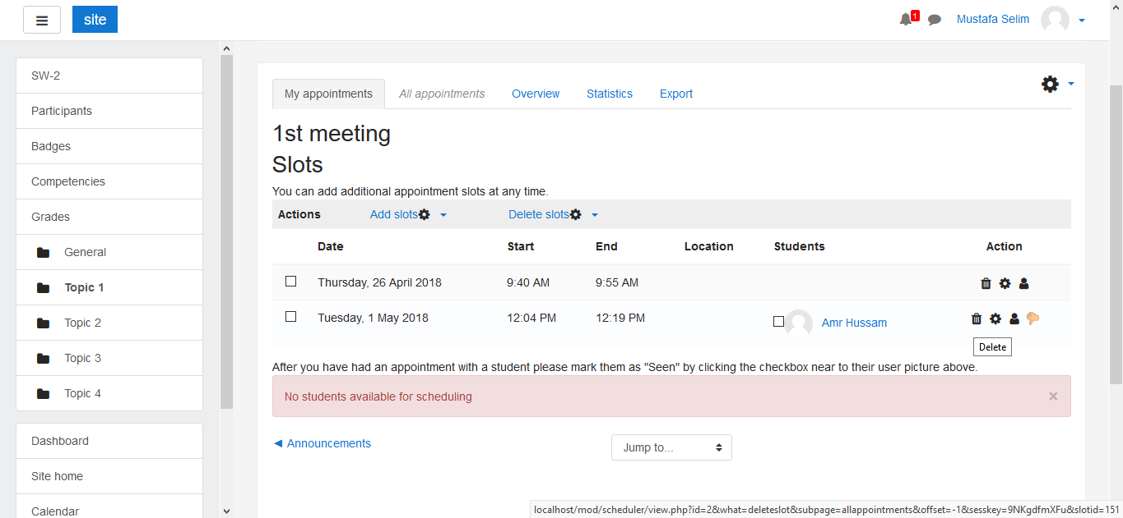Further, teachers can use a web form for manually sending invitations or reminders to students who did not yet make an appointment.

